MERN REAL ESTATE MANAGEMENT SYSTEM



Submitted By:
- Muhammad Ihtisham Sajjad (233535)
- Zohaib Siddique (233517)
- Muhammad Shabir (233601)
Submitted To:
- Sir Rashaf Jamil Khan

1. Introduction
This document presents a comprehensive Real Estate Management System developed using the MERN stack (MongoDB, Express.js, React.js, Node.js). The system is designed to streamline and automate real estate operations for developers, agencies, societies, and investors, enabling efficient management of multiple projects, plots, buyers, and financial workflows. It provides a centralized platform to track transactions, manage commissions, oversee installment plans, and generate detailed operational and financial reports.
The system covers the following key areas:
- Operational workflows
- Financial modules
- Plot management
- Buyer and seller ledgers
- Commissions management
- Installment and payment tracking
- Partner profit distribution
- Project management
- Reporting and analytics
- Automation of calculations and workflows
This structure ensures accurate, real-time insights into all aspects of real estate operations while reducing manual work and errors.

2. System Goals & Objectives
The Real Estate Management System aims to fully automate all operations, from project and plot management to sales, payments, and reporting. It tracks buyers, sellers, agents, and plots in a centralized database while managing flexible installment plans and receivables. The system ensures accurate project-wise financial tracking and automatically calculates profit distribution for partners based on their investment shares. It supports CSV/Excel bank imports with auto-matching, provides interactive dashboards and detailed operational and financial reports, and minimizes human errors by automating calculations for commissions, payments, and ledgers
3. High-Level Modules Overview
✔Operational Reports
✔ Partner & Investment Management
✔ Financial Accounting
✔ Plot & Project Management
✔ Seller & Buyer Ledger
✔ Installments & Payment Plans
✔ Commission Management
✔ Bank Accounts & CSV Upload
✔ Payroll
✔ Visualization Dashboard
✔ User Roles & Permissions

4. Detailed Module Breakdown
4.1 Operational Reports
These reports give an overview of daily operations.
1. Sales Register
- Contains:
- Plot information
- Buyer details
- Total amount
- Payment plan
- Payments received
- Balance receivable
2. Receivables Aging
Breaks unpaid amounts into:
- 0–30 days
- 31–60 days
- 61–90 days
- 90+ days
3. Plot Status Summary
Shows:
- Available plots
- Sold plots
- Blocked plots
- Disputed plots
- In transfer
4. Commission Summary
Shows:
- Agent commissions earned
- Commission released
- Commission pending
5. Monthly Progress Report (MPR)
Includes:
- Sales summary
- Collection summary
- New plots opened
- Expenses
- Profit generated

4.2 Partner Profile & Investment Management
Partner Profile Fields
- Partner Name
- Share %
- Investment Amount
- Joining Date
- Contact details
Investment Tracking
- Capital injected
- Profit credited
- Withdrawals
- Running balance
Profit Distribution
- Automatically calculates partner profit based on:
- Project profit
- Share %
Reports
- Partner-wise capital
- Profit summary
- Withdrawals history
- Project-wise distribution logs

4.3 Financial Reports
1. Profit & Loss Statement
- Project-wise or overall:
- Revenue
- Cost
- Expenses
- Net profit
2. Balance Sheet
- Assets
- Liabilities
- Equity
3. Cash Flow Statement
- Tracks:
- Inflows
- Outflows
- Net cash position

4.4 Payroll Module
Features
- Add employees
- Set monthly salaries
- Allowances
- Deductions
- Attendance history
- Payroll reports

4.5 Bank Accounts Management
Supports Multiple Accounts
Examples:
- HBL Sales
- MCB Operations
- UBL Collections
- Meezan Investments
Transaction Import System
- Upload CSV or Excel
- Extract fields (date, debit, credit, description)
- Auto-match with system entries
- Flag mismatches
- Auto-suggestions

4.6 Commission Management (Agent/Broker)
Purpose
Auto-calculate agent commissions.
Commission Rules
Per project/plot:
- Fixed amount
- Percentage of sale
- Based on received installment
- Tiered commission (optional)
Automation
- When buyer pays → Commission auto-calculated
- Release commission → auto-update agent ledger
Reports
- Pending commissions
- Released commissions
- Agent-wise breakdown

4.7 Seller (Landowner) Payment Tracking
Purpose
Manage payments to the original landowner from whom the plot was purchased.
Seller Profile Fields
- Name
- CNIC
- Contact
- Plots linked
- Payable amount
- Paid amount
Payment Modes
- Lump sum
- Installments
Automation
- When buyer pays installment → seller due updated
- Auto-generate seller payment voucher
- Update seller ledger
Reports
- Pending payments to sellers
- Payment log
- Seller-wise summary

4.8 Installments & Payment Plans
Plan Types
- Monthly
- Quarterly
- Bi-annual
- Custom
Plan Creation Fields
- Buyer
- Plot
- Total Amount
- Down Payment
- No. of Installments
- Installment Amount
- Start Date
- Status
Auto Reminders
- Overdue reminder
- Upcoming installment reminder

4.9 Project-Wise Plot Management (Marla-Based)
Project Details
- Project Name
- Location
- Total Area (Marla)
- Status (Planning / Ongoing / Completed)
Plot Details
- Plot No.
- Size (Marla)
- Block
- Phase
- Facing
- Status (Available / Sold / Blocked / Disputed)
Ownership Mapping
- Link plots to buyers
- Link plots to sellers
- Support co-ownership
- Transfer logs
Visual Dashboard
- Map/grid view
- Click to view plot details
- Status color coding

4.10 Customer Ledger & Receivables Management
Entities
- Buyer
- Seller
- Agent/Broker
Fields
- Name
- CNIC/NTN
- Contact
- Address
- Type (Buyer/Seller/Agent)
- Status (Active/Inactive)
Ledger View
- Running balance
- Full debit/credit history
- Outstanding amount
- Aging breakdown
Features
- Search
- Filters
- Export PDF/Excel
- Link to plots/projects
- Quick entry

5. System Architecture (MERN)
Layer | Technologies / Tools | Key Features / Components
Frontend | React.js | • Pages • Components • Context API / Redux • Protected routes • Charts & tables
Backend | Node.js + Express | • REST API • Middleware • Authentication • Validation
Database | MongoDB | Collections for: • Projects • Plots • Buyers • Sellers • Agents • Payments • Installments • Transactions • Commissions • Partners • Profit distribution • Bank records

6. User Roles & Permissions
Roles
- Admin
- Accountant
- Sales officer
- Agent
- Partner
- Viewer only
- Each role has specific permissions for CRUD operations.

7. Automation Logic
Examples
✔ Commission auto-calculated when buyer pays
✔ Seller payable updated automatically
✔ Partner profit distribution auto-run monthly
✔ Plot status auto-changed when sold
✔ Ledger balances updated automatically
✔ CSV import auto-matches bank transactions

8. Dashboards
Admin Dashboard
- Total sales
- Total receivables
- Pending seller payments
- Monthly profit
- Project comparison
Project Dashboard
- Plots status
- Collection progress
- Installments graph
- Agent performance

9. Technology Stack
Frontend
- React.js
- Tailwind / Material UI
- Redux Toolkit
Backend
- Node.js
- Express.js
- JWT authentication
Database
- MongoDB + Mongoose
Utilities
- Multer (file upload)
- XLSX (Excel processing)
- Nodemailer (email)
- Morgan (logging)

10. Future Enhancements
✔ WhatsApp/SMS reminders
✔ Mobile app version
✔ Real-time dashboard using WebSockets
✔ AI-based plot recommendation
✔ OCR-based bank import

Sequence Diagram:
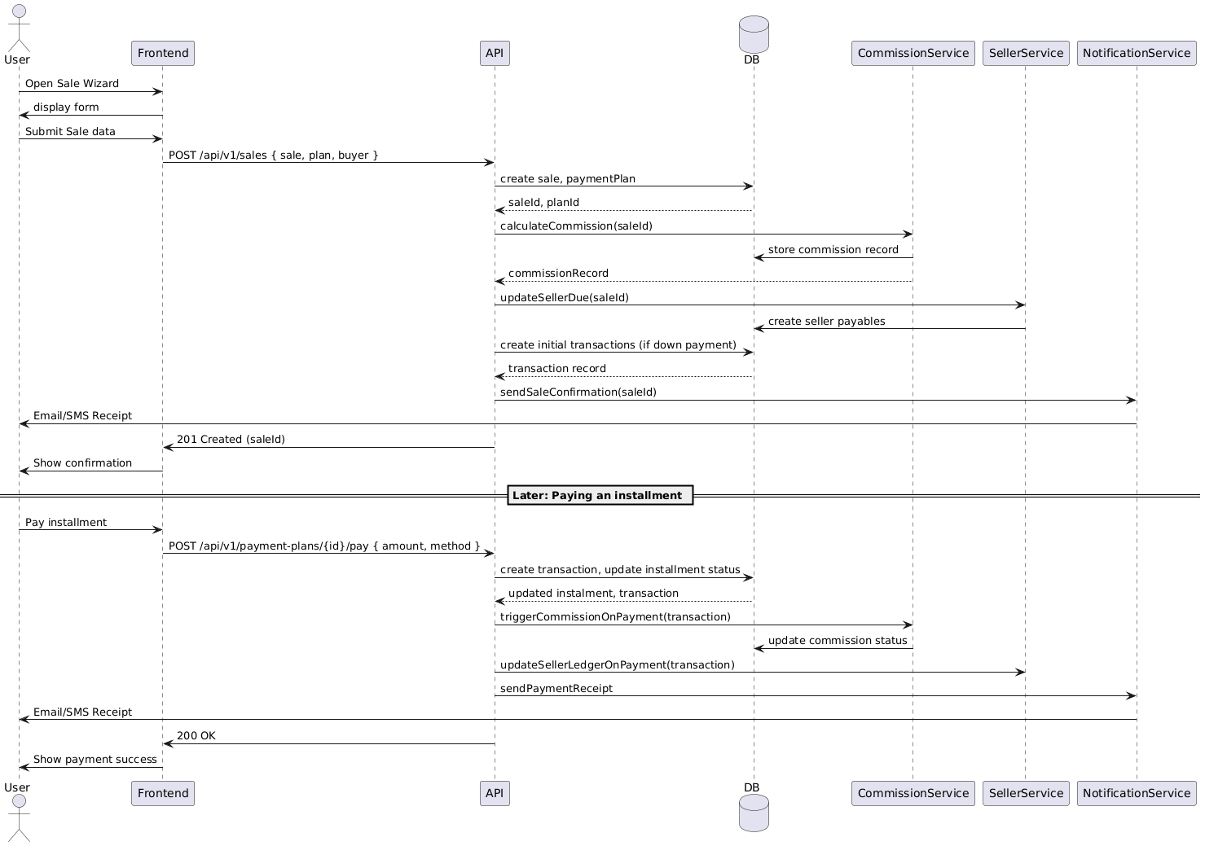
Flowchart:
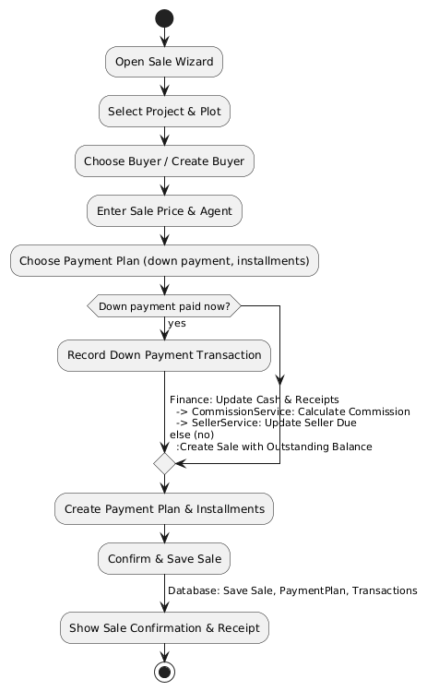

Class Diagram:
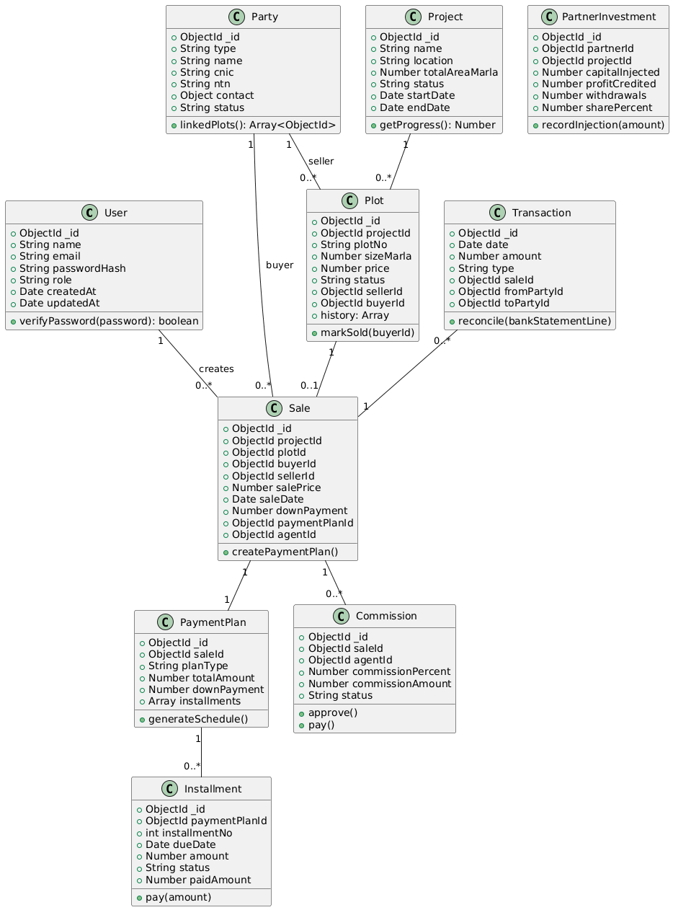
ERD Diagram:
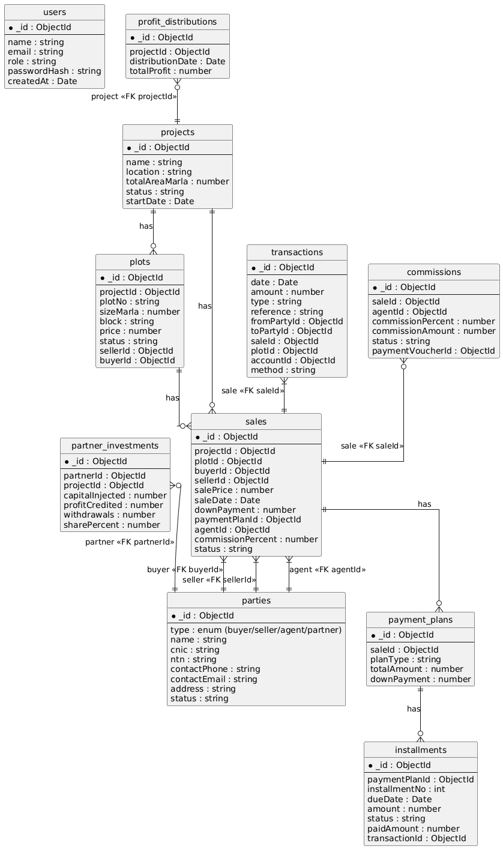

11. Conclusion
This MERN-based Real Estate System is designed to automate the entire business workflow of a real estate company. It handles plot management, payments, installments, commissions, partners, ledgers, and reporting with accuracy and efficiency.

